Topic 6: Customer relationship

What is costumer relationship?
Customer Relations (CR) refers to the methods, strategies, and processes a company employs to build and maintain relationships with customers. Every interaction with customers influences the success of companies, enhancing their competitiveness. Therefore, companies develop new strategies and approaches for interacting with customers that constantly meet expectations. They research and explore customer needs to attract new ones and retain existing ones. Various loyalty programs are developed to improve customer relationships. The employee-customer relationship is examined to help the company receive adequate feedback on the state of its products and services, provide ideas for improvements to existing ones or the creation of new ones. Efforts are made to improve service and provided services through customer feedback systems, expanding opportunities to deal with new customers and entering new markets, and many other tasks aimed at increasing the company's competitiveness and winning more customers.
In general, CR encompasses all activities aimed at establishing, developing, and maintaining successful relationships between the customer and the company.
Key elements of CR:
- Trust;
- Respect;
- Value;
- Open communication;
- Constructive conflicts;
- Responsibility.
Trust - in the absence of trust, there is no way to carry out transactions between the customer and the merchant, especially in the long term. Therefore, trust between them is of crucial importance. The most general definition of trust is provided by Murman, namely as a clear expressed desire to rely on a partner we trust [1]. In CR, trust is a two-way process, i.e., it must be mutual. Lack of trust on one side would lead to uncertainty in the relationship. According to Dyankov [2], trust is built on stability (fairness, accuracy, sincerity). Building trust is a long-term process that requires certain skills and efforts, both from the company and from the customer. Various tools such as reasoning, guarantees, promises, etc., are used to build mutual trust between the customer and the company.
Respect - it is a prerequisite for good relationships. Mutual respect means partnership between the parties in negotiations and agreements. It is an attitude towards the other party and is based on tact, politeness, and courtesy.
Value proposition - another important element is the value of the product and the way the customer perceives it. Does the customer perceive the product in the way the company expects? Is it as valuable to him as the company claims? Successfully positioning the product high in the eyes of the customer is a guarantee of success. Value is most easily built in the eyes of the customer when the product's competitive advantages are presented in the best possible way according to the customer's needs and desires. At the same time, from the customer's point of view, does he understand what you are giving him, and does he appreciate its value? Does he appreciate the extras he receives from the company, the special offers, the small (and large) gestures of goodwill? For the company, it is important to receive good reviews for its products in addition to the price (recommendations, word-of-mouth advertising, clearly expressed preferences from the customer towards its product). Value is also based on reciprocity from both interested parties, which improves their relationship and strengthens the connection.
Figure 1. Key elements of customer relationships

Open communication - Strong relationships are built through continuous, frequent, and above all, honest communication with the customer. According to Brian Tracy, in order to double sales, the number of meetings with the customer must double. Conversations with the customer, continuous clarification of their needs and desires are a guarantee of successful sales. Communicating with the customer helps determine whether the competitive advantages of the product, which the company assumes, are perceived as such in their eyes. Honest communication with them serves to identify conflict situations, win sympathies, and build mutual trust. According to Brian Tracy, requesting recommendations from customers who have already been served is a powerful tool for creating new business opportunities and reaching new customers [3].
Constructive conflicts - According to management theory, a constructive conflict is a confrontation that strengthens and enhances results at work, while the absence of constructive conflicts means stagnation and standing still [4]. From the company's point of view, constructive conflicts mean that the seller is not afraid to engage in principled confrontation with their customer, for example, to defend the qualities of their product, their trade conditions, or their price. Proper understanding of conflict as a form of communication is a prerequisite for building mutual respect and trust - elements necessary for building good relationships with customers.
Responsibility - It is an important factor for good customer relationships and means that both the customer and the company-seller stand by their words. In the event of something unexpected or undesirable happening (such as poor quality of goods/services, delay in delivery, delayed payment terms, etc.), the respective party should take responsibility and compensate the affected party with specific actions. Responsibility is usually something that is regulated by contract, but besides the documentary side of things, responsibility in sales is associated with open communication, respect, value, and trust.

Customer Relationship Management
The term "Customer Relationship Management" (CRM) represents a comprehensive concept and business strategy for developing and maintaining customer relationships. It is based on integrating communication channels, data processing, and coordinating the efforts of all departments within the company that are involved with customers in one way or another.
Essence of CRM - it represents a strategic approach to attracting and retaining customers, improving relationships with them, analyzing their behavior and needs, and maintaining long-term and sustainable relationships with customers who can rely on quality service and certain discounts from the company [5]. The components of CRM are threefold:
- Customer - viewed as the primary source of doing business and generating revenue over the long term;
- Relationship - contacts between customers and the company through various channels (face-to-face, phone, email, social media, exhibitions, direct mail, etc.);
- Management - involves the process of systematizing and analyzing customer information from employees within the company, with the possibility of then offering advantageous deals.
Objectives of CRM - the main goal of CRM is to increase the efficiency of the organization's business processes by attracting and retaining customers with whom the company [5] interacts during its marketing activities, sales, and services it offers. Other objectives of CRM include:
- expanding opportunities to close deals with new customers and enter new markets;
- improving service and provided services through feedback systems with customers (online or via phone calls);
- increasing sales through marketing strategies, such as active promotion and discounts for loyal customers;
- building and maintaining relationships of loyalty and honesty with customers;
- reducing costs by eliminating losing activities within the company.
To implement the CRM concept, the following CRM tasks need to be fulfilled (figure 2).
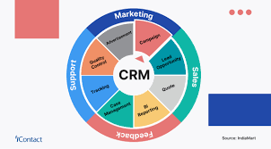
Figure 2. CRM tasks [6]

Identification of customers - storing and processing individual customer information. This includes identifying the customer and instant access to their profile when contact is made. This profile is built from the database collected from all departments of the company. Through the customer profile, it is easier to understand their needs and respond to them adequately.
Differentiation of customers - here the principle of the Italian economist Pareto can be applied, which states: "20% of customers account for 80% of sales, and the remaining 80% of customers generate 20% of sales," showing the need for special service and attention to those customers who contribute to higher company revenues.
Interaction with customers - here it is necessary to have information on the history of relationships with customers to track customer preferences and attempts to satisfy them through various methods of communication: websites, email, phone calls, SMS, mail. The goal here is to maintain good relationships with customers by offering various offers and discounts for the company's products and services in all possible ways.
Personalization of customers - each customer is rated by the company, and they are served accordingly, with different promotions being made for those with higher ratings. Periodically, emails/SMS messages are sent thanking customers for their purchases, using the feedback system for customer reviews, comments, and recommendations to improve the quality of the company's products and services.

Customer Relationship Management (CRM) Systems - Functions and Classification
Customer Relationship Management (CRM) system represents a set of applications through which information about customers is gathered. This information is processed, stored, and exported, providing in a format convenient for making management decisions. The main functions of the CRM system are:

- Information gathering: This information is collected in a unified database of the company, with data inputted by either an employee of the company or the customer themselves. All available data about customers, such as personal information and interactions with the company, are entered into the CRM system.
- Processing and storing information: This is done through technologies and corresponding applications implemented by the company, which analyze the inputted data to further export the information to various levels and departments of the company.
- Exporting information: This is an important function that allows the use of information in different departments of the company, where employees can see what products or services can be offered to the customer based on past purchases. For regular customers, the system reminds that various discounts are available.
Classification of CRM systems:
In practice, there is a wide variety of customer relationship management systems that could be classified based on different indicators.
Depending on their purpose, CRM systems are divided into:
- Operational CRM systems: These systems are used by company employees for operational access to information about specific customers during direct interaction with them, i.e., in the process of sales and service. The main component of this system is an application that provides employees with the gathered information about the given customer in a suitable format.
- Analytical CRM systems: This type of system is used for analyzing various data related to both the customer themselves and analyzing the activities of the company. Analytical CRM systems use customer and company data to track certain patterns in order to create an effective marketing strategy to increase sales volume and improve the quality of customer service.
- Communication CRM systems: These systems provide customers with significant influence over the company's activities, such as the production of specific products and their delivery methods. This is done through communication channels such as the internet and telephone, where customers communicate their needs and expectations regarding the products they are interested in. Based on this, the management team of the company gathers and decides what innovations and technologies to use in order to meet the needs of the customers.
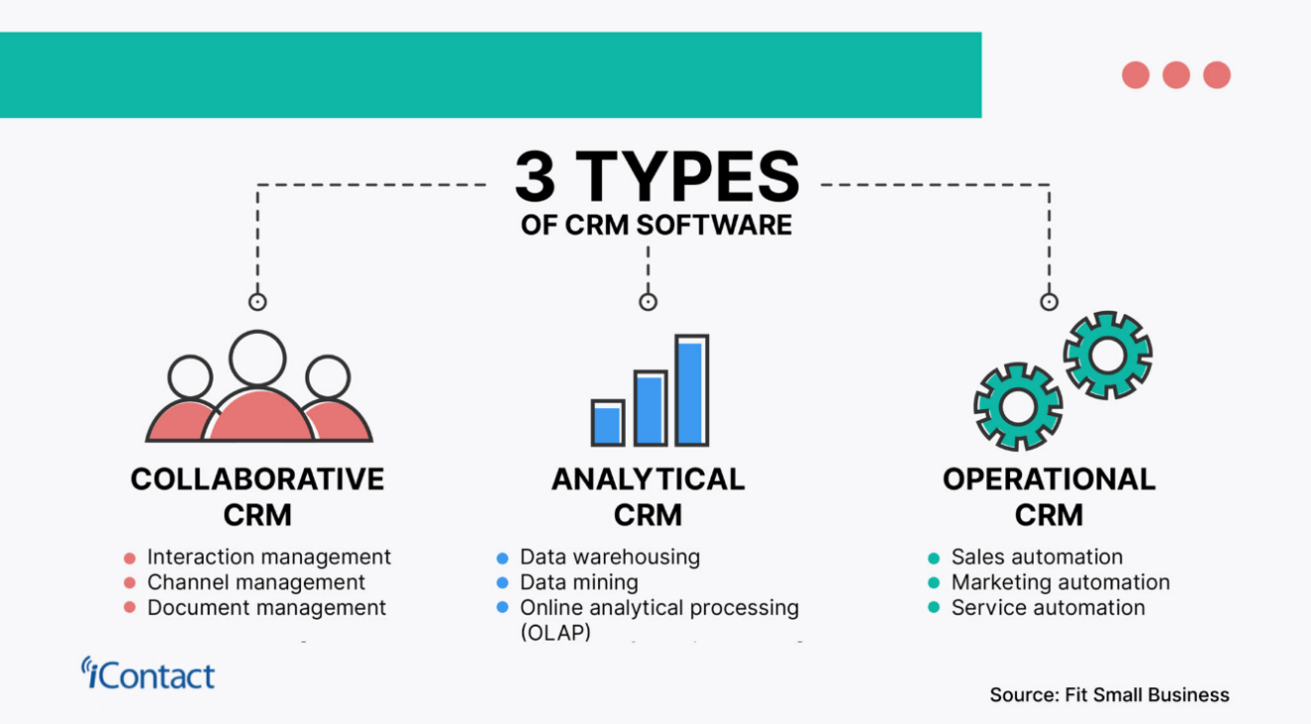
Figure 3. Main CRM types [7]
We can summarize that operational CRM systems are systems with applications that provide employees with operational access to information about specific customers in the process of business interactions with them, such as servicing, sales, and delivery.
Analytical CRM systems process and analyze various data from customers and the company in order to provide marketing strategies for more effective sales and higher quality customer service.
Communication CRM systems use various channels such as the internet, telephone, and email to reach customers and understand their needs and expectations for specific products. Customers can provide ideas and suggestions for product design and delivery methods.
According to the way they connect with customers, CRM systems are divided into:
- Office CRM systems: These are intended for stationary work with customers visiting the offices of firms and having direct contact with their employees.
- Remote CRM systems: Where customer orders for goods and services are accepted via the internet or by phone, with customers often being at a great distance from the company offering these products and services.
- Contact centers (Call centers): Through which customer information is received via telephone calls, processed, and stored in the database management system. Generally, a database is understood as a set of data structured in a way that allows for easy and quick retrieval, browsing, searching, and minimizing data duplication. The application software that provides the ability to work with the database is called a database management system (DBMS).
In summary, office CRM systems are suitable for relatively small firms, with data inputted by employees or customers themselves. Remote CRM systems are suitable for medium and large firms, with orders usually placed remotely via the internet or telephone.

Contact centers are oriented towards large companies where the number of customers is large. Through phone calls, information about customer preferences and personal information is gathered, processed, and stored in the database management system.

Strategies for managing customer relationships
Customer Relationship Management (CRM) encompasses all aspects of interaction between the company and its customers, with the primary goals being to better understand customer needs, attract new customers, retain existing ones through better service, increase company revenue, and reduce costs. To achieve all these goals, an adequate CRM strategy or set of CRM strategies is required to meet the company's business objectives while simultaneously addressing customer needs.
Let's examine some of the most important CRM strategies that are crucial for developing better business relationships with customers:
- Analytical Strategy: This strategy utilizes a system of programs that analyze customer data and preferences, enabling more effective business decisions by company management.
- Process Redesign Strategy: This involves analyzing processes within and outside the company, and if necessary, redesigning business processes such as sales, delivery, and customer service. The focus here is on leveraging the advantages of new technologies such as the internet, wireless communications, and other innovations to improve competitiveness, productivity, and company revenue, while also enhancing the quality of customer service.
- Marketing Strategy: This CRM strategy is primarily aimed at attracting new customers and retaining existing ones using marketing methods through various channels such as TV media, websites, email, phone, SMS, and mail.
- Customer Service: This CRM strategy is one of the key factors in maintaining existing customers and attracting new ones. The most important aspect here is to maximize customer satisfaction by establishing "customer service points" where customers can return unsatisfactory goods, provide feedback, and make recommendations for specific products to enhance their quality.

Benefits of Implementing CRM Strategies:
The benefits of implementing CRM Strategies can be summarized as:
- Increased Revenue and Profits: Finding the right CRM software that aligns with the company's business strategies and goals enables management to develop CRM strategies that increase sales and profits in the long term. This is made possible by CRM software that provides access to customer databases for their purchases and preferences, significantly facilitating employees to select and implement the right CRM strategy.
- Conversion of Potential Customers into Real Ones: This is achieved through CRM strategies that target a large number of potential customers by offering them favorable deals through various communication channels (internet, phone, mail). The goal is for these potential customers to be convinced of the quality of the company's products and services, thereby increasing future sales and profits for the company.

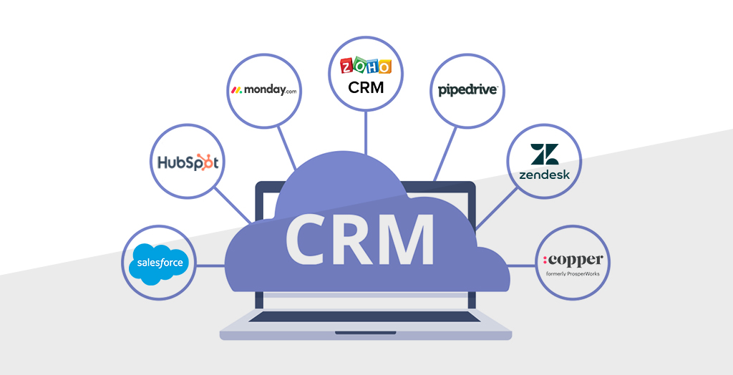
Figure 4. 7 Best CRM Software 2021[8]
- Improved Customer Service: This is achieved through the use of various CRM strategies, such as customer service and feedback from customers. Customer service is often provided at designated points where users can make complaints and recommendations for certain products or services, while customer feedback is most often obtained via the internet (email), phone, or mail, where company employees ask/send questions to customers about their satisfaction with purchased products or services. This way, maximum customer satisfaction is achieved, and the quality of the products and services offered by the company is improved.
CRM systems can be paid for, but there are also open-source ones. Forbes publishes an annual ranking of the best CRM systems for the year, as well as those with open source code [9].
In conclusion, by using an appropriate CRM strategy and software product, high sales and profits can be achieved for the company, and administrative expenses can be reduced. CRM systems provide quick access to customer databases, from which queries can be made about their preferences and facilitate the selection of an adequate CRM strategy by the company's management. This way, greater customer satisfaction is achieved, and through various marketing strategies, the attraction of new customers is supported, leading to the possibility of achieving higher sales and revenues for the company.

Questions for Self-Evaluation:

What are the main elements of customer relationships?
What are the main functions of Customer Relationship Management (CRM) systems?
What CRM systems do you know?
What are the main tasks of CRM systems?

Test Questions:

1. What are the main elements of customer relationships?
a) trust, respect, value proposition, security;
b) trust, respect, value proposition, security, conflicts, communication;
c) trust, respect, value proposition, conflicts, communication, responsibility;
d) none of the above

2. Systems where customer orders for goods and services are accepted via the internet or by phone are called:
a) analytical CRM systems;
b) stationary CRM systems;
c) remote CRM systems;
d) Contact centers;
e) none of the above

3. In which strategy do we analyze processes inside and outside the company, and if necessary, redesign business processes?
a) analytical strategy;
b) marketing strategy;
c) vertical integration strategy;
d) "process redesign" strategy;
e) differentiation strategy.

4.In which strategy do we primarily attract new customers and retain existing ones?
a) analytical strategy;
b) marketing strategy;
c) vertical integration strategy;
d) "process redesign" strategy;
e) differentiation strategy.

5. The main functions of a CRM system are:
a) gathering, processing, storing, and exporting information;
b) gathering and processing information, differentiating and interacting with customers;
c) identifying, differentiating, interacting, and personalizing customers;
d) none of the above

References
[1] Moorman, R and others. Relationships between providers and users of marketing research: The dynamics of trust within and between organizations. // Journal of Marketing Research, vol. 29 (3), 1992, p. 314 – 329
[2] https://eknigibg.net/Volume1/Issue2/spisanie-br2-2015-pp.54-63.pdf
[3] „Психология на продажбите“ – Брайън Трейси
[4] Шестте елемента на добрите взаимоотношения в продажбите, Обновена на 24.10.2020 от Тодор Христов https://www.novavizia.com/shestte-elementa-na-dobrite-vzaimootnosheniya-v-prodajbite/
[5] Kraeva V., Popova P., Marinova N., Marinova K., ELECTRONIC CUSTOMER RELETIONSHIP MANAGEMENT SISTEMS-STATE OF THE ARTAND CAPABILITY IN FINACIAL SECTOR IN BULGARIA, https://dialogue.uni-svishtov.bg/dialog_old/2012/INI/04-statia-2012.pdf , Dialogue, Svishtov, 2012
[6] https://www.icontact.com/define/customer-relationship-management/
[7] https://www.icontact.com/define/customer-relationship-management/
[8] 7 Best CRM Software 2021, https://www.aceinfoway.com/blog/crm-software-comparison , POSTED: June 9, 2021
[9] https://www.forbes.com/advisor/business/software/best-open-source-crm/

